#include<iostream>
using namespace std;

void swapNumbers(int &x, int &y){
int temp = x;
x = y;
y = temp;

cout<<"after swaping x: "<<x<<" and y: "<<y<<endl;
}

int main(){
int a = 24;
int b = 79;
cout<<"Before Swapping x: "<<a<<" and y: "<<b<<endl;
swapNumbers(a,b);
}
```

This program swaps two numbers using **pass by reference**. It prints the values before and after swapping. Output would be:
```
Before Swapping x: 24 and y: 79
after swaping x: 79 and y: 24
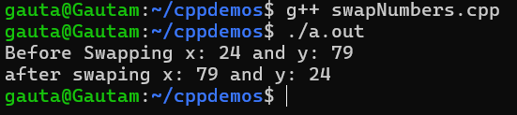

2.#include<iostream>
using namespace std;

void prtstr(int size){
string name[size];

for(int i = 0; i<size; i++){
cout<<"Enter the "<<i + 1<<" name: "<<endl;
cin>>name[i];
}

for(int i = 0; i<size; i++){
cout<<"Name of no "<<i + 1<<" student is: "<<name[i]<<endl;
}
}
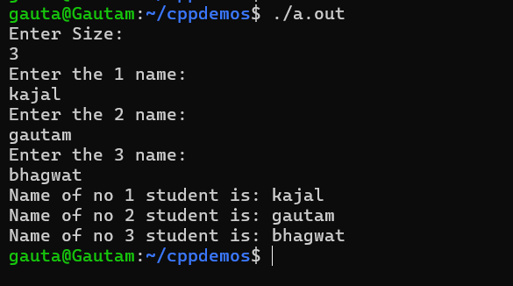

3.int main(){
int size;
cout<<"Enter Size: "<<endl;
cin>>size;

prtstr(size);
return 0;
}
#include <iostream>
using namespace std;

int fact(int n){
if(n == 1){
return 1;
}

return n * fact(n-1);
}

int main(){
int n;
cout<<"enter the value of n: "<<endl;
cin>>n;

for(int i = 1; i<=n; i++){
cout<<fact(i)<<endl;
}
return 0;
}

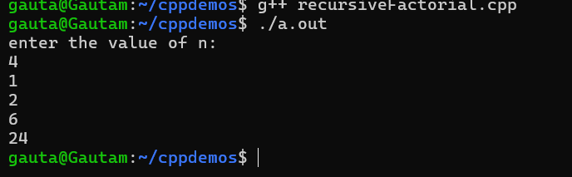

4.
#include <iostream>
using namespace std;

void reverse(string *str, int size){
if(size == 0){
cout<<str[size];
return;
}

cout<<str[size];
size--;
reverse(str, size);
return;
}

void ip(int size){
string str[size];
char ch[size];
for(int i = 0; i<size; i++){
cout<<"Enter char "<<i+1<<" : "<<endl;
cin>>ch[i];

str[i] = ch[i];
}

reverse(str, size - 1);
}

int main(){
int size;
cout<<"Enter Size of Char array: "<<endl;
cin>>size;
ip(size);
return 0;
}
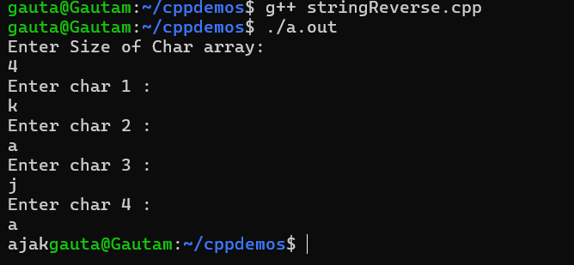

5.
#include<iostream>
#include<cstring>
using namespace std;

class Student{
private:
int rollNo;
char sName[20];
public:
Student(){
sName[0] = '\0';
rollNo = 0;
}

void setRollNo(int roll){
rollNo = roll;
}

void setName(const char *name){
strcpy(sName, name);
}

void setStudentInfo(){
cout<<"Enter the roll No: "<<endl;
cin>>rollNo;
cout<<"Enter the Student Name: "<<endl;
cin>>sName;
}

void display(){
cout<<"Name: "<<sName<<", Roll No: "<<rollNo<<endl;
}
};

int main(){
int n = 2;
Student *s = new Student[n];

for(int i = 0; i < n; i++){
s[i].setStudentInfo();
}

for(int i = 0; i < n; i++){
s[i].display();
}

delete[] s;
return 0;
}

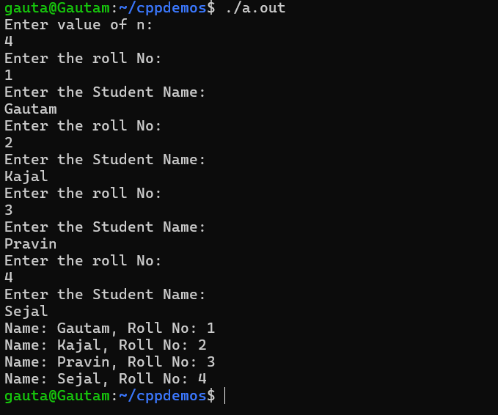
6.
#include<iostream>
using namespace std;

void sortArray(int size){
int *arr = new int[size];

for(int i = 0; i < size; i++){
cout<<"Enter "<<i<<" position value: "<<endl;
cin>>arr[i];
}

for(int i = 0; i < size - 1; i++){
for(int j = 0; j < size - i - 1; j++){
if(arr[j] > arr[j + 1]){
int temp = arr[j];
arr[j] = arr[j + 1];
arr[j + 1] = temp;
}
}
}

cout<<"Sorted array is: "<<endl;
for(int i = 0; i < size; i++){
cout<<arr[i]<<endl;
}

delete[] arr;
}

void printString(int size){
char ch[size];
string str[size];

for(int i = 0; i < size; i++){
cout<<"Enter Character: "<<endl;
cin>>ch[i];
str[i] = ch[i];
}

for(int i = 0; i < size; i++){
cout<<str[i];
}

cout<<endl;
}

void avg(int n){
int value;
int sum = 0;

for(int i = 0; i < n; i++){
cout<<"Enter the "<< i + 1 <<" no value: "<<endl;
cin>>value;
sum += value;
}

cout<<"Average is: "<<(float)sum / n <<endl;
}

void mult(int n){
int value;

for(int i = 0; i < n; i++){
cout<<"Enter the "<< i + 1 <<" no value: "<<endl;
cin>>value;
cout<<value<<" * 2 = "<< value * 2 <<endl;
}

cout<<endl;
}
int main(){
int n;
do{
cout<<"1. Sort Array"<<endl;
cout<<"2. Print String"<<endl;
cout<<"3. Average"<<endl;
cout<<"4. Multiply by 2"<<endl;
cout<<"5. Exit"<<endl;
cout<<"Choice: ";
cin>>n;
switch(n){
case 1: {
int s;
cout<<"Enter Size of Array: "<<endl;
cin>>s;
sortArray(s);
break;
}
case 2: {
int p;
cout<<"Enter Size of Array: "<<endl;
cin>>p;
printString(p);
break;
}
case 3: {
int q;
cout<<"Enter size of n: "<<endl;
cin>>q;
avg(q);
break;
}
case 4: {
int r;
cout<<"Enter value of n: "<<endl;
cin>>r;
mult(r);
break;
}
case 5:
cout<<"Thank You for Visiting!"<<endl;
break;

default:
cout<<"Wrong Choice"<<endl;
}

}while(n != 5);
return 0;
}

